SMART WORKLOAD MANAGER
A Project Based Learning Report Submitted in partial fulfilment of the requirements for the award of the degree
of
Bachelor of Technology
in The Department of Computer Science and Engineering
OPERATING SYSTEMS / SYSTEM PROGRAMMING

OPERATING SYSTEMS AND SYSTEMS PROGRAMMING and 25CS2104E

Under the guidance of
Dr.Pavan Kumar Pagadala

Department of Computer Science Engineering
Koneru Lakshmaiah Education Foundation, Aziz Nagar
Aziz Nagar – 500075
OCT - 2026

Abstract
Smart Workload Manager is a Linux-based workload monitoring and decision-support system developed to identify resource-intensive processes and recommend safe workload actions based on CPU usage, memory usage, and workload importance. When several workloads run simultaneously, background processes may consume system resources and affect an important or primary workload. The proposed system addresses this problem through a role-aware workflow rather than automatic process termination.
The implemented workflow is Monitor → Analyze → Identify → Recommend → Log. The system obtains process information from the Linux /proc filesystem, analyzes CPU and memory usage, calculates a combined workload score, classifies workload intensity, and considers whether a process is a primary or background workload. Based on these conditions, the manager can recommend review or resource reduction for a high-load background workload, protection for a high-load primary workload, monitoring for a medium workload, or continued execution for a low workload.
The project is implemented in C for Linux and uses operating-system mechanisms including fork(), exec()/execl(), waitpid(), pipes where implemented, POSIX threads, mutex-based synchronization where implemented, file handling, and Linux system calls. The implemented user menu provides system workload viewing, primary workload selection, specific-process analysis, report generation, workload decision and recommendation, resource hotspot detection, sample workload launching, activity-history viewing, and system summary.
A verified experiment observed sample_workload at PID 3063 with state R, CPU usage of 100.00%, memory usage of 1820 KB, a workload score of 55/100, and HIGH classification. When treated as a background workload, the recommendation was REVIEW; when selected as the primary workload, the recommendation was PROTECT. This demonstrates the central role-aware decision-making idea of the project: the same resource condition can lead to different recommendations depending on workload importance.
Keywords: Linux, Process Monitoring, CPU Usage, Memory Usage, Workload Scoring, Role-Aware Decision Making, Inter-Process Communication, POSIX Threads, System Calls, Activity Logging

List of Figures
Figure 1: Smart Workload Manager System Architecture
Figure 2: Overall Workload Management Flow
Figure 3: Project Source Structure
Figure 4: Main Menu
Figure 5: High-Load Workload Analysis
Figure 6: Workload Decision and Recommendation
Figure 7: Primary Workload Protection
Figure 8: Workload Scoring Method
Figure 9: Activity History / Logging

List of Tables
Table 1: Functional Requirements
Table 2: Software/Hardware Requirements
Table 3: Workload Scoring Criteria
Table 4: Workload Classification
Table 5: Test Cases
Table 6: Experimental Results
Table 7: OS Concepts Used
Table 8: Review 3 Rubric Alignment

Abbreviations
Table: Abbreviations Used
Abbreviation | Meaning
OS | Operating System
CPU | Central Processing Unit
RAM | Random Access Memory
PID | Process Identifier
IPC | Inter-Process Communication
POSIX | Portable Operating System Interface
GNU | GNU's Not Unix
/proc | Linux Process Information Virtual Filesystem
PBL | Project Based Learning
CSE | Computer Science and Engineering

Table of contents
1. INTRODUCTION
1.1 Background
1.2 Problem Statement
1.3 Motivation
1.4 Objectives
1.5 Scope of the Project

2. LITERATURE / EXISTING SYSTEM
2.1 Existing Workload Monitoring Approaches
2.2 Limitations of Existing Approaches
2.3 Need for the Proposed System
2.4 Proposed System

3. SYSTEM ANALYSIS AND REQUIREMENTS
3.1 Functional Requirements
3.2 Non-Functional Requirements

4. SYSTEM DESIGN
4.1 System Architecture
4.2 Overall Workflow
4.3 Process Monitoring
4.4 Workload Scoring
4.5 Workload Classification
4.6 Role-Aware Decision Mechanism
4.7 Logging and Activity History

5. IMPLEMENTATION
5.1 Implementation Overview
5.2 Project Structure
5.3 Process Monitoring Module
5.4 Analyzer Module
5.5 IPC Module
5.6 Logger Module
5.7 Workload Thread Module
5.8 Sample Workload Generation
5.9 Main Menu and User Interaction

6. OPERATING SYSTEM CONCEPTS USED
6.1 Processes, fork(), exec()
6.2 /proc Filesystem
6.3 Inter-Process Communication
6.4 Pipes
6.5 Threads
6.6 Mutex/Synchronization
6.7 System Calls

7. TESTING AND EXPERIMENTATION
7.1 Testing Methodology
7.2 High-Load Workload Test
7.3 Primary Workload Test
7.4 Decision Recommendation Test

8. RESULTS AND DISCUSSION
8.1 High-Load Detection Result
8.2 Workload Score Result
8.3 Background Workload Recommendation
8.4 Primary Workload Protection
8.5 Activity Logging
8.6 Overall Outcome

9. CONCLUSION AND FUTURE SCOPE
9.1 Conclusion
9.2 Limitations
9.3 Future Enhancements
10.REFERENCES

1. INTRODUCTION

1.1 Background
Modern Linux systems commonly execute multiple processes at the same time. Some processes are directly related to the user's primary task, while others operate in the background. When a background workload consumes a significant amount of CPU or memory, it can create resource contention and reduce the responsiveness of an important workload.
Traditional monitoring tools can show CPU, memory, and process information, but a raw list of resource values does not always answer the operational question of what should be done next. Smart Workload Manager therefore focuses on decision support. It converts resource observations into a workload score and combines that score with workload importance to recommend a safer action.
The project follows the sequence Monitor → Analyze → Identify → Recommend → Log. Monitoring obtains process information, analysis evaluates resource usage, identification classifies workload intensity and role, recommendation selects an appropriate action, and logging records activity for later review.

1.2 Problem Statement
When multiple workloads run simultaneously, background processes can consume CPU and memory resources and affect the important or primary workload. A monitoring solution is therefore required to identify resource-intensive workloads and provide a clear recommendation without taking unsafe automatic action.
The project specifically avoids automatic process termination. Instead, it recommends whether a workload should be reviewed, monitored, kept running, or protected.

1.3 Motivation
The motivation for the project is to bridge the gap between resource monitoring and workload-aware decision support. A high CPU value alone does not necessarily mean that a process should be stopped. A high-load process may be the user's most important workload. The project therefore introduces role-aware decision making so that resource intensity and workload importance are considered together.

1.4 Objectives
• Monitor running Linux processes and obtain CPU and memory information.
• Analyze individual workloads and identify resource-intensive processes.
• Calculate a combined workload score from CPU and memory contributions.
• Classify workload intensity as CRITICAL, HIGH, MODERATE, or LOW.
• Allow the user to select a primary workload.
• Recommend REVIEW, MONITOR, KEEP RUNNING, or PROTECT actions based on workload condition and role.
• Identify resource hotspots using top CPU and memory usage.
• Launch a sample workload for controlled experimentation.
• Maintain activity/history information through logging.
• Provide workload reports and a system summary without automatically terminating processes.

1.5 Scope of the Project
The project scope covers Linux process monitoring, workload scoring, role-aware recommendation, sample workload generation, activity logging, and user-driven decision support. It is intended as an operating-systems-oriented prototype implemented in C.
The project does not claim automatic process termination, deadlock detection or prevention, machine-learning-based prediction, or a graphical dashboard. Such capabilities may be considered future enhancements.
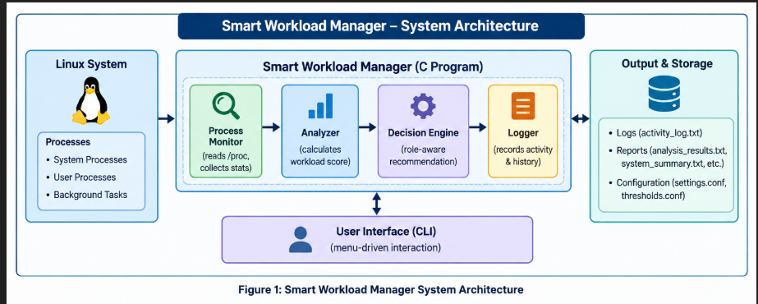
Conceptual architecture placeholder. Replace with the final project architecture diagram if required by the submission.
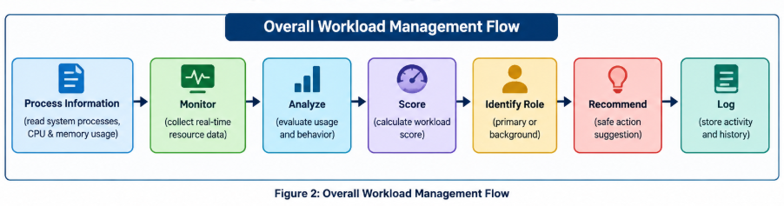
Conceptual flow: Process Information → Monitor → Analyze → Score → Identify Role → Recommend → Log.

2. LITERATURE / EXISTING SYSTEM

2.1 Existing Workload Monitoring Approaches
Linux provides several mechanisms for observing running processes and system resources. The /proc filesystem exposes process-specific information, while command-line monitoring utilities present CPU and memory observations to users. Such mechanisms are useful for identifying active processes and resource consumption.
Operating-system process management also provides mechanisms for creating processes, executing programs, synchronizing parent and child processes, and communicating between processes. These mechanisms form the technical foundation on which a monitoring and decision-support application can be built.

2.2 Limitations of Existing Approaches
Resource monitoring by itself mainly presents measurements. A user may still need to interpret whether a process is important, whether its resource consumption is acceptable, and what action is safer. A high CPU process may be either an undesirable background workload or the primary task that should be protected. Therefore, resource magnitude alone is insufficient for role-aware workload decisions.

2.3 Need for the Proposed System
There is a need for a lightweight Linux-based system that converts resource observations into an understandable workload classification and recommendation. The proposed approach emphasizes safe decision support instead of automatic termination. This makes the system suitable for demonstrating operating-system concepts while keeping the user in control.

2.4 Proposed System
Smart Workload Manager monitors process information, analyzes CPU and memory usage, computes a workload score, identifies workload intensity and role, and generates a recommendation. The system supports a primary-workload selection mechanism so that important workloads can be protected even when their resource usage is high.
The strongest idea of the proposed methodology is role-aware decision making: the recommended action depends not only on resource usage but also on the importance of the workload.

3. SYSTEM ANALYSIS AND REQUIREMENTS

3.1 Functional Requirements
Table 1: Functional Requirements
ID | Requirement
FR1 | View current system workload and running process information.
FR2 | Select a process as the primary workload.
FR3 | Analyze a specific process using CPU and memory information.
FR4 | Generate a workload report.
FR5 | Generate workload decision and recommendation.
FR6 | Identify CPU and memory resource hotspots.
FR7 | Launch a sample workload for experimentation.
FR8 | View activity history and logged actions.
FR9 | Display a system summary.
FR10 | Exit without automatically terminating monitored processes.

3.2 Non-Functional Requirements
• Safety: recommendations are advisory; no automatic process termination is performed.
• Clarity: workload classifications and actions should be understandable to the user.
• Portability: the implementation targets a Linux environment using C and standard Linux/POSIX facilities.
• Maintainability: functionality is separated into monitoring, analysis, IPC, logging, and workload-thread modules.
• Responsiveness: process information should be gathered and presented through a command-line interface.
• Traceability: important workload activities can be recorded in history/log files.

4. SYSTEM DESIGN

4.1 System Architecture
The architecture is organized into a monitoring layer, analysis layer, role-aware decision layer, and logging/output layer. The monitoring component obtains process information. The analyzer converts resource measurements into a score and classification. The decision component considers workload role. The logger records activity, while the command-line interface allows the user to invoke project functions.
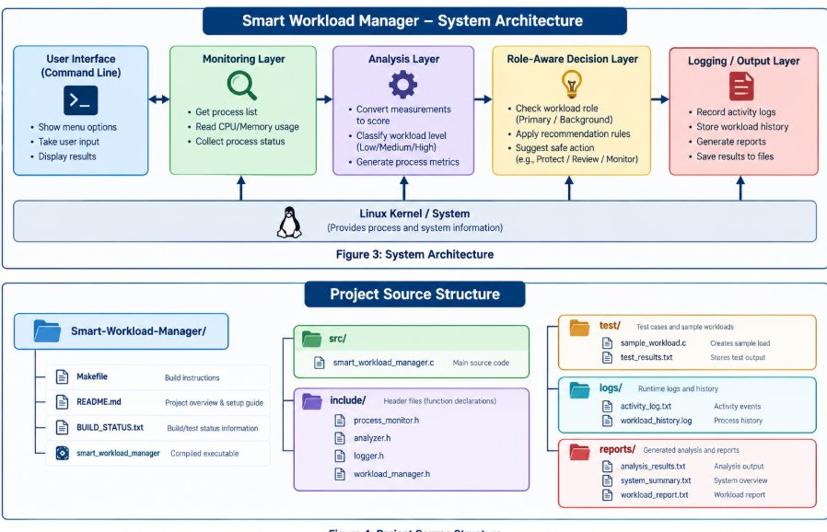

4.2 Overall Workflow
The overall workflow is Monitor → Analyze → Identify → Recommend → Log. The user can first inspect system workload, select a primary workload when needed, analyze a specific process, and then request a workload decision. The system reports the recommendation without automatically stopping the process.

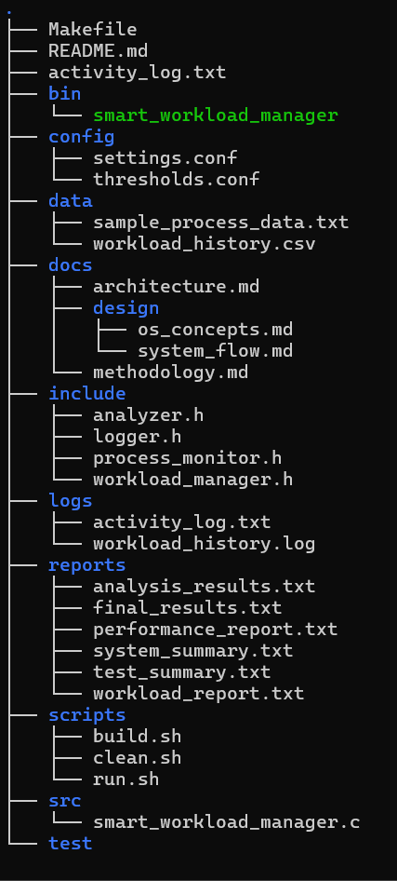
Figure 4

4.3 Process Monitoring
Process monitoring uses Linux process information exposed through /proc. Process identifiers and relevant resource information are collected and interpreted so that the application can display system workload and analyze specific processes.

4.4 Workload Scoring
The workload score combines CPU and memory resource usage. CPU contributes a maximum of 50 points and memory contributes a maximum of 50 points. The resulting value is used to classify workload intensity.
Table 2: Workload Scoring Criteria – CPU Contribution
CPU Usage | CPU Points
CPU ≥ 80% | 50
CPU ≥ 50% | 40
CPU ≥ 20% | 30
CPU ≥ 5% | 15
Otherwise | 5

Table 3: Workload Scoring Criteria – Memory Contribution
Memory Usage | Memory Points
Memory ≥ 1 GB | 50
Memory ≥ 512 MB | 40
Memory ≥ 128 MB | 25
Memory ≥ 32 MB | 15
Otherwise | 5

Final Score = CPU Contribution + Memory Contribution. Therefore, a process with 100.00% CPU usage receives 50 CPU points. A memory value of 1820 KB is below 32 MB and therefore contributes 5 memory points, producing the verified score of 55/100.

4.5 Workload Classification
Table 4: Workload Classification
Score Range | Classification
Score ≥ 80 | CRITICAL
Score ≥ 50 | HIGH
Score ≥ 25 | MODERATE
Otherwise | LOW

4.6 Role-Aware Decision Mechanism
Role-aware decision making is the central design principle. The manager does not interpret a high score as an instruction to terminate a process. Instead, it considers the workload role.
Table 5: Role-Aware Recommendation Rules
Condition | Recommended Action
High-load background workload | REVIEW / REDUCE RESOURCE USAGE
High-load primary workload | PROTECT
Medium workload | MONITOR
Low workload | KEEP RUNNING

This mechanism ensures that workload importance changes the recommendation. The same process and resource condition can be interpreted differently when it is a background workload compared with when it is selected as the primary workload.

4.7 Logging and Activity History
The logger records relevant workload activity and decision information in project log files. Activity history allows the user to review previous observations and recommendations. Logging supports traceability without changing the monitored process automatically.
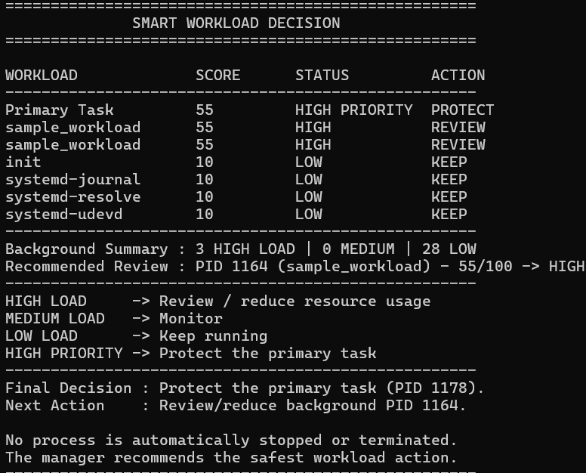 [
Figure 5: Workload Scoring Method
Show the final project scoring diagram: CPU contribution + Memory contribution → Score /100 → CRITICAL/HIGH/MODERATE/LOW.
5. IMPLEMENTATION

5.1 Implementation Overview
Smart Workload Manager is implemented in C for Linux. The project is organized into separate source modules so that process monitoring, analysis, inter-process communication, logging, workload-related threading, and the main user interface remain logically separated.

5.2 Project Structure
The implemented project structure is:
src/
main.c
process_monitor.c
analyzer.c
ipc.c
logger.c
workload_threads.c
include/
test/
sample_workload.c
logs/
reports/
Makefile
README.md
BUILD_STATUS.txt
smart_workload_manager

5.3 Process Monitoring Module
process_monitor.c is responsible for obtaining process information required by the manager. It works with Linux process information and supports viewing system workload and analyzing specific processes.

5.4 Analyzer Module
analyzer.c implements the workload scoring and classification logic. CPU and memory measurements are converted into contributions, combined into a score, and mapped to CRITICAL, HIGH, MODERATE, or LOW.

5.5 IPC Module
ipc.c contains inter-process communication functionality used where implemented. Pipes provide a mechanism for exchanging information between related processes when the project workflow requires it.

5.6 Logger Module
logger.c is responsible for recording activity and workload-history information. The logs directory stores generated activity information so that decisions and observations can be reviewed.

5.7 Workload Thread Module
workload_threads.c contains workload-related concurrent execution using POSIX threads and mutex-based synchronization where implemented. The module supports the project demonstration of concurrent workload activity and synchronization.

5.8 Sample Workload Generation
test/sample_workload.c provides the sample workload used for experimentation. The manager can launch the sample workload through process creation and program execution mechanisms, allowing the monitoring and scoring logic to be tested under a controlled workload.

5.9 Main Menu and User Interaction
The main program provides the implemented command-line menu:
Table 6: Implemented Menu Functions
Option | Implemented Function
1 | View System Workload
2 | Select Primary Workload
3 | Analyze Specific Process
4 | Generate Workload Report
5 | Workload Decision & Recommendation
6 | Resource Hotspots (Top CPU/Memory)
7 | Launch Sample Workload
8 | View Activity History
9 | System Summary
10 | Exit

6. OPERATING SYSTEM CONCEPTS USED

6.1 Processes, fork(), exec()
A process is a running instance of a program with its own execution context and resources. Smart Workload Manager monitors processes and uses process identifiers to distinguish workloads.
fork() is used for process creation where the project needs a child process to perform a separate workload or launch sequence. The child and parent execution paths can then be coordinated using the project's process-control logic.
exec()/execl() replaces the child process image with the selected executable. In this project it is relevant to launching the sample workload from the manager.

6.2 /proc Filesystem
Linux provides process and system information through the virtual /proc filesystem. The project reads relevant process information from this interface for monitoring and analysis.

6.3 Inter-Process Communication
IPC allows separate processes to exchange information. The project includes an IPC module and uses IPC mechanisms where implemented to support workload-related communication.

6.4 Pipes
pipe() provides a unidirectional communication channel between processes. It is used where implemented by the project to pass information between related execution contexts.

6.5 Threads
POSIX threads allow concurrent execution within a process. The project includes a workload thread module for workload-related concurrent execution.

6.6 Mutex/Synchronization
A mutex provides mutual exclusion when shared data must be accessed safely by concurrent threads. The project uses mutex-based synchronization where implemented in the workload thread functionality.

6.7 System Calls
The implementation uses Linux/POSIX system-level interfaces for process creation, execution, synchronization, IPC, and process information. These calls form the operating-system foundation of the application.
Table 7: OS Concepts Used
Concept | Project Usage
Processes | Monitor running workloads and identify PIDs
fork() | Create process execution contexts where required
exec()/execl() | Launch the sample workload
/proc | Obtain Linux process information
IPC | Workload-related process communication where implemented
pipe() | Inter-process communication where implemented
POSIX threads | Workload-related concurrent execution
Mutex | Synchronization where implemented
System calls | Linux/POSIX system-level operations

7. TESTING AND EXPERIMENTATION

7.1 Testing Methodology
Testing was organized around the implemented menu functions and the role-aware workload decision logic. The main experimental objective was to verify that a resource-intensive process can be measured, scored, classified, and assigned a role-dependent recommendation without automatic termination.

7.2 Test Environment
• Linux operating system environment
• C implementation built as smart_workload_manager
• Sample workload executable from test/sample_workload.c
• Terminal-based project interaction
• Activity and report directories available in the project structure

7.3 High-Load Workload Test
The verified high-load experiment monitored sample_workload at PID 3063. The observed state was R, CPU usage was 100.00%, memory usage was 1820 KB, and the calculated workload score was 55/100. The workload was classified as HIGH and, when treated as a background workload, the recommendation was to REVIEW or reduce resource usage.

7.4 Primary Workload Test
After PID 3063 was selected as the primary workload, the system reported the primary task as PID 3063, score 55, status HIGH PRIORITY, and action PROTECT. This demonstrates that workload role affects the recommendation.

7.5 Decision Recommendation Test
Before selecting a primary workload, the verified decision output was: sample_workload, Score 55, Status HIGH, Action REVIEW. The system then stated that a primary task must be selected first and identified the next action as reviewing/reducing background PID 3063.
The verified system statement is: “No process is automatically stopped or terminated. The manager recommends the safest workload action.”
Table 8: Test Cases
Test ID | Test Case | Expected Behaviour | Verified Observation
T1 | View system workload | Display running workload information | Supported by project menu
T2 | Analyze PID 3063 | Calculate CPU/memory score | 100.00% CPU, 1820 KB, 55/100
T3 | Background decision | Recommend REVIEW for high-load background | Verified
T4 | Select PID 3063 as primary | Treat high-priority workload as protected | Verified PROTECT
T5 | Resource hotspots | Identify top CPU/memory workloads | Implemented menu function
T6 | Activity history | Display logged workload activity | Implemented menu function

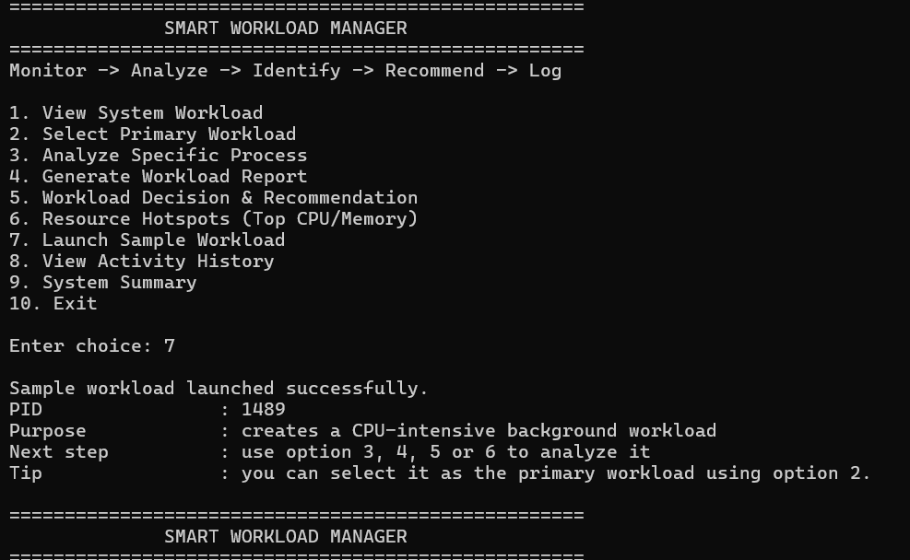

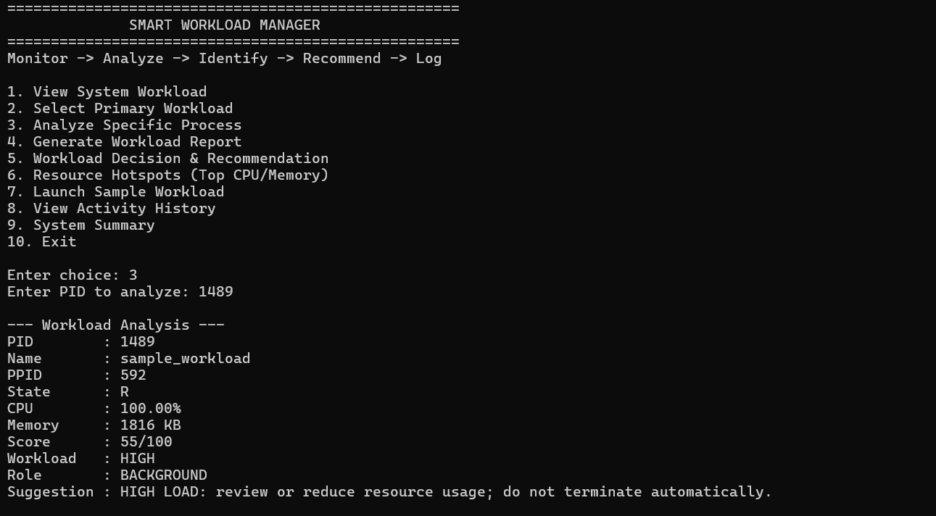8. RESULTS AND DISCUSSION

8.1 High-Load Detection Result
The main verified experiment detected sample_workload with PID 3063 in state R and CPU usage of 100.00%. The observation demonstrates that the monitoring component can identify a resource-intensive workload and provide the measurements needed for subsequent analysis.

8.2 Workload Score Result
The verified memory value was 1820 KB. According to the implemented scoring thresholds, 100.00% CPU contributes 50 points and 1820 KB memory contributes 5 points. Therefore: 50 + 5 = 55/100. The resulting classification is HIGH.

8.3 Background Workload Recommendation
When sample_workload was considered a BACKGROUND workload, the verified result was: Score 55, Status HIGH, Action REVIEW. The recommendation was “HIGH LOAD: review or reduce resource usage; do not terminate automatically.”

8.4 Primary Workload Protection
After PID 3063 was selected as the primary task, the verified result was: Score 55, Status HIGH PRIORITY, Action PROTECT. The final decision was to protect the primary task. This is the clearest demonstration of role-aware workload management: the resource measurements remained the same, but the recommended action changed because the workload role changed.

8.5 Activity Logging
The project includes an activity-history function and a logger module. The purpose of logging is to preserve workload observations and recommendations for later review. Actual log screenshots should be inserted in the final submission if required.

8.6 Overall Outcome
The project demonstrates the complete intended decision-support path: Problem → Monitoring → Analysis → Workload Scoring → Role Identification → Recommendation → Logging → Result. The implementation does not automatically terminate processes and does not claim predictive or machine-learning functionality.
Table 9: Experimental Results
Test | Process | CPU | Memory | Score | Classification | Role | Recommendation
High-load background | sample_workload | 100.00% | 1820 KB | 55/100 | HIGH | BACKGROUND | REVIEW
Primary workload | sample_workload | 100.00% | 1820 KB | 55/100 | HIGH | PRIMARY | PROTECT

These are verified project observations supplied for the project documentation and are reported as experimental results, not theoretical examples.

9. CONCLUSION AND FUTURE SCOPE

9.1 Conclusion
Smart Workload Manager is a Linux-based operating-systems project that provides workload monitoring, analysis, scoring, role identification, and safe recommendation. The project addresses a practical problem in which background processes may consume resources needed by an important workload. Instead of automatically terminating processes, the system gives the user a recommendation based on measured workload intensity and workload role.
The verified experiment observed sample_workload at PID 3063 using 100.00% CPU and 1820 KB memory. The resulting score was 55/100 and the classification was HIGH. As a background workload, the recommended action was REVIEW; as a primary workload, the action was PROTECT. This verifies the central role-aware concept of the project.

9.2 Limitations
• The current system provides recommendations rather than automatic workload control.
• The reported experiment is a verified observation and should not be interpreted as a universal benchmark.
• The current interface is terminal-based.
• Workload thresholds are fixed according to the implemented scoring methodology.
• Long-term workload trends and predictive analysis are not currently implemented.
• Deadlock prevention/detection is not claimed as part of the project.

9.3 Future Enhancements
• Historical workload trend analysis.
• Graphical dashboard for CPU, memory, score, and role information.
• Notifications and alerts for sustained high-load conditions.
• Adaptive thresholds based on observed system behaviour.
• Predictive workload analysis using machine learning.
• Improved workload prioritization and additional workload roles.
• Long-term resource usage analytics and comparative reports.
These features are future scope only and are not presented as implemented functionality in the current project.

10.REFERENCES
[1] A. Silberschatz, P. B. Galvin, and G. Gagne, Operating System Concepts, Wiley, relevant chapters on processes, threads, synchronization, and inter-process communication.
[2] M. Kerrisk, The Linux Programming Interface, No Starch Press, 2010.
[3] Linux man-pages Project, Linux Programmer's Manual: fork(2), exec(3), waitpid(2), pipe(2), pthreads(7), and related process/system-call documentation.
[4] The Open Group, The Open Group Base Specifications / POSIX.1, IEEE Std 1003.1, process, thread, synchronization, and system-interface specifications.
[5] Linux Kernel Documentation, documentation on the /proc filesystem and process information interfaces.
[6] W. Stallings, Operating Systems: Internals and Design Principles, Pearson, sections on processes, threads, scheduling, and resource management.
[7] R. Love, Linux System Programming: Talking Directly to the Kernel and C Library, O'Reilly Media, 2013.

